**ISO 20022**

Post Trade Foreign Exchange Messages

Maintenance 2016/2017 - approved by Foreign Exchange SEG on 13 March 2017

**Message Definition Report** **- Part 1**

Edition January 2019

Table of contents

1. Introduction 4

1.1 Terms and definitions 4

1.2 Glossary 4

1.3 Document Scope and Objectives 5

1.4 References 5

2. Scope and Functionality 6

2.1 Background 6

2.2 Scope 6

2.3 Groups of MessageDefinitions and Functionality 6

2.3.1 Six administration messages 6

2.3.2 Four cash management messages 6

2.3.3 Two reference data Messages 7

2.3.4 Seven foreign exchange trade messages 7

3. BusinessRoles and Participants 8

4. BusinessProcess Description 9

4.1 BusinessProcess Diagram 9

5. Description of BusinessActivities 11

5.1 BusinessProcess – Trade Instruction and Trade Notification 12

5.2 BusinessProcess – Amend Trade Instruction and Trade Notification 13

5.3 BusinessProcess – Cancel /Withdrawal of Trade Instruction and Trade Notification 15

5.4 BusinessProcess – Fixing of an NDF Opening Trade Instruction and Notification 17

5.5 BusinessProcess – Pay-In Schedule and Pay-In Schedule Event Acknowledgement 18

5.6 BusinessProcess – Pay-In Call and Pay-In Event Acknowledgement 19

5.7 BusinessProcess – Static Data Request and Report 19

5.8 BusinessProcess – Net Report 20

6. BusinessTransactions 21

6.1 Foreign Exchange Trade Instruction and Foreign Exchange Trade Status and Details Notification BusinessTransaction 21

6.2 Amend Trade Instruction and Trade Notification BusinessTransaction 21

6.3 Cancel/Withdrawal Trade Instruction and Trade Notification BusinessTransaction 22

6.4 Fixing of an NDF Opening Trade Instruction and Trade Notification BusinessTransaction 23

*6.5* *Pay In Schedule and Pay-In Event Acknowledgement BusinessTransaction* 24

6.6 Pay In Call and Pay-In Event Acknowledgement BusinessTransaction 25

6.7 Static Data Request and Report BusinessTransaction 25

6.8 Net Report BusinessTransaction 26

7. Examples 27

7.1 Foreign Exchange Trade Instruction - fxtr.014.001.04 27

7.2 Foreign Exchange Trade Instruction Amendment - fxtr.015.001.04 28

7.3 Foreign Exchange Trade Instruction Cancellation - fxtr.016.001.04 29

7.4 Foreign Exchange Trade Withdrawal Notification - fxtr.013.001.03 30

7.5 Foreign Exchange Trade Status Notification - fxtr.008.001.06 30

7.6 Foreign Exchange Trade Status And Details Notification - fxtr.017.001.04 31

7.7 Foreign Exchange Trade Bulk Status Notification - fxtr.030.001.04 33

7.8 Foreign Exchange NDF Opening Trade Instruction - fxtr.014.001.04 33

7.9 Foreign Exchange NDF Fixing Trade Instruction - fxtr.014.001.04 35

7.10 Foreign Exchange Trade Status and Details Notification (NDF) - fxtr.017.001.04 36

7.11 Message Reject – admi.002.001.01 38

7.12 System Event Notification – admi.004.001.02 38

7.13 Static Data Request - admi.009.001.02 38

7.14 Static Data Report - admi.010.001.02 39

7.15 System Event Acknowledgment - admi.011.001.01 39

7.16 Pay In Call - camt.061.001.02 40

7.17 Pay In Schedule - camt.062.001.03 40

7.18 Pay In Event Acknowledgement - camt.063.001.02 42

7.19 Net Report – camt.088.001.01 42

8. Revision Record 45

**Preliminary note:**

The Message Definition Report (MDR) is made of three parts:

* **MDR - Part 1** describes the contextual background required to understand the functionality of the proposed message set. Part 1 is produced by the submitting organisation that developed or maintained the message set in line with a MDR Part1 template provided by the ISO 20022 Registration Authority (RA) on [www.iso20022.org](http://www.iso20022.org)
* **MDR – Part 2** is the detailed description of each message definition of the message set. Part 2 is produced by the RA using the model developed by the submitting organisation.
* **MDR – Part 3** is an extract of the ISO 20022 Business Model describing the business concepts used in the message set. Part 3 is an Excel document produced by the RA.

# Introduction

## Terms and definitions

The following terms are reserved words defined in ISO 20022 – Part1. When used in this document, they will follow the UpperCamelCase notation.

|  |  |
| --- | --- |
| Term | Definition |
| BusinessRole | Functional role played by a business actor in a particular BusinessProcess or BusinessTransaction |
| Participant | Involvement of a BusinessRole in a BusinessTransaction |
| BusinessProcess | Unrealized definition of the business activities undertaken by BusinessRoles within a BusinessArea whereby each BusinessProcess fulfils one type of business activity and whereby a BusinessProcess may include and extend other BusinessProcesses |
| BusinessTransaction | Particular solution that meets the communication requirements and the interaction requirements of a particular BusinessProcess and BusinessArea |
| MessageDefinition | Formal description of the structure of a MessageInstance |

## Glossary

**Acronyms**

|  |  |
| --- | --- |
| Acronym | Definition |
| FX | Foreign Exchange |
| BIC | Business Identifier Code |
| CSD | Central Securities Depository |
| ACH | Automated Clearing House |
|  |  |

**Abbreviations**

|  |  |
| --- | --- |
| Abbreviation | Definition |
| Ack | Acknowledgement |
|  |  |
|  |  |

## Document Scope and Objectives

This document is the first part of the ISO 20022 Message Definition Report (MDR) that describes the BusinessTransactions and underlying message set. For the sake of completeness, the document may also describe BusinessActivities that are not in the scope of the project.

This document sets:

* The BusinessProcess scope (business processes addressed or impacted by the project)
* The BusinessRoles involved in these BusinessProcesses

The main objectives of this document are:

* To explain what BusinessProcesses and BusinessActivities these candidate MessageDefinitions have addressed
* To give a high level description of BusinessProcesses and the associated BusinessRoles
* To document the BusinessTransactions and their Participants (sequence diagrams)
* To list the candidate MessageDefinitions

## References

| Document | Version | Date | Author |
| --- | --- | --- | --- |
| ISO20022BJ_PostTradeFXSupplement_CLS_v2 | V2 | 10/06/2016 | CLS Bank |
| ISO20022MCR_PostTradeFX_Maintenance_2016_2017_v3 | V3 | 18/11/2016 | CLS Bank |
| ISO 20022 Business Justification –75 Post Trade Foreign Exchange Messages |  | 30-09-2013 | CLS Bank |
| ISO20022_Bank-to-CustomerCashManagement_MDR1.pdf |  | 28-5-2013 | SWIFT |
| ISO20022_Bank-to-CustomerCashManagement_MDR2.pdf |  | 28-5-2013 | SWIFT |
| Forex Notifications.pdf |  | 9-5-2007 | SWIFT |

# Scope and Functionality

## Background

This Message Definition Report covers a set of 19 ISO 20022 MessageDefinitions developed by CLS Bank and approved by the Foreign Exchange Standards Evaluation Group (SEG). These messages are specifically designed to support matching, netting and settlement processing of foreign exchange trades.

As a result of the updates made in the 2016/2017 maintenance cycle, new versions have been created for the following messages: fxtr.014, fxtr.015, fxtr.016, fxtr.017, fxtr.030 and fxtr.008. As a result of a new development, the following four new messages were added to the message set: admi.019, camt.088, read.060 and reda.061.

## Scope

The set of messages covers the post-trade processing in the foreign exchange trade domain together with cash management and administration messages to support the associated payments processing and notification of system events.

## Groups of MessageDefinitions and Functionality

**Note that these MessageDefinitions are to be used with the ISO 20022 Business Application Header (head.001). The schema and more information about the Business Application Header (BAH) can be found on the** [**www.iso20022.org**](http://www.iso20022.org/bah.page) **web site.**

This set of messages includes the following MessageDefinitions:

### Six administration messages

* Message Reject (admi.002) is a message that is sent by a central system to a participant of the central system to notify the rejection of a message previously received from the participant.
* System Event Notification (admi.004) is a message sent by a central system to notify the occurrence of an event in the central system.
* Static Data Request (admi.009) is a message that is sent by a participant of a central system to the central system to request a static data report.
* Static Data Report (admi.010) is a message that is sent by a central system to the participant to provide static data held in the system.
* System Event Acknowledgement (admi.011) is a message that is sent by a participant of a central system to the central system to acknowledge the notification of an occurrence of an event in a central system.
* Processing Request (admi.019) is a message that is sent by a participant of a central system to the central system to request the initiation of a process executed by the central system

### Four cash management messages

* Pay In Call (camt.061) is a message that is sent by a central settlement system to request additional funding from a settlement member impacted by a failure situation.
* Pay In Schedule (camt.062) is a message that is sent by a central settlement system to the participant to provide notification of a series of timed payments scheduled for each currency at the time and date of the schedule generation. The central settlement system may send information about how the timed payments have been calculated.
* Pay In Event Acknowledgement (camt.063) is a message that is sent by a participant of a central system to the central system to confirm a PayInSchedule or a PayInCall has been received.
* Net Report (camt.088) is a message generated by a central system responsible for the netting of transactions between participants. The message is sent by the central system to a participant to provide details of the bi-lateral payment obligations per currency between participant pairs.

### Two reference data Messages

* Netting Cut Off Reference Data Update Request (reda.060) is a message sent from a participant of a central system to the central system requesting an update to a netting cut off held for the participant at the central system
* Netting Cut Off Reference Date Report (reda.061) is a message generated by a central system to inform participants of updates to netting cut offs held at the central system

### Seven foreign exchange trade messages

* Foreign Exchange Trade Instruction (fxtr.014.001) is a message that is sent by a participant to a central system to notify the creation of the foreign exchange trade agreed by both trading parties.
* Foreign Exchange Trade Instruction Amendment (fxtr.015.001) is a message that is sent by a participant to a central system to notify the amendment of the foreign exchange trade previously confirmed by the sender.
* Foreign Exchange Trade Instruction Cancellation (fxtr.016.001) is a message that is sent by a participant to a central system to notify the cancellation of the foreign exchange trade previously confirmed by the sender.
* Foreign Exchange Trade Status and Details Notification (fxtr.017.001) is a message that is sent by a central system to the participant to provide notification of the status and details of a foreign exchange trade.
* Foreign Exchange Trade Status Notification (fxtr.008.001) is a message that is sent by a central system to the participant to notify the current status of a foreign exchange trade in the system. This message will be sent at specific times agreed upon by the central system and a participant in a central system.
* Foreign Exchange Trade Bulk Status Notification (fxtr.030.001) is a message that is sent by a central system to the participant to provide notification of the current status of one or more foreign exchange trades.
* Foreign Exchange Trade Withdrawal Notification (fxtr.013.001) is a message that is sent by a central system to notify the withdrawal of a foreign exchange trade which was previously notified to the receiver as an alleged trade. The message is used to confirm the cancellation of a previously notified trade.

# BusinessRoles and Participants

A BusinessRole represents an entity (or a class of entities) of the real world, physical or legal, a person, a group of persons, a corporation. Examples of BusinessRoles: “Financial Institution”, “ACH”, “CSD”.

A Participant is a functional role performed by a BusinessRole in a particular BusinessProcess or BusinessTransaction: for example the “user” of a system, “debtor”, “creditor”, “investor” etc.

The relationship between BusinessRoles and Participants is many-to-many. One BusinessRole (that is, a person) can be involved as different Participants at different moments in time or at the same time: "user", "debtor”, "creditor", "investor", etc. Different BusinessRoles can be involved as the same Participant.

In the context of Post Trade Foreign Exchange, the high-level BusinessRoles and typical Participants can be represented as follows.

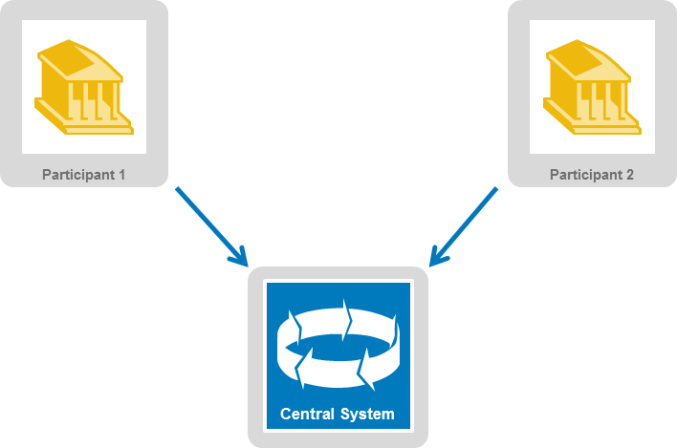

| **Participants and BusinessRoles definitions** | |
| --- | --- |
| **Description** | **Definition** |
| BusinessRoles | |
| Trading Party | Party that originated the foreign exchange trade. This party may be the same as the submitting party. |
| Submitting Party | Party that submits the foreign exchange trade to the matching system or to the system or to the counterparty. |
| Matching system | System that matches foreign exchange trade instructions for its participants. |
| Settlement system | System that matches and settles foreign exchange trade instructions for its participants. |
| Netting System | System that matches and nets foreign exchange trade instructions for its participants. |
| Participants | |
| Central System | Party that processes, matches and nets or settles foreign exchange trades on behalf of system member institutions. |
| Participant | Party that is a member of the central system through which they match and net/settle foreign exchange trades.. |

|  |  |  |  |  |  |
| --- | --- | --- | --- | --- | --- |
|  | **BusinessRoles/Participants Matrix Table** | | | | |
| BusinessRoles  Participants | Trading Party | Submitting Party | Central System | | |
| Matching System | Settlement System | Netting System |
| Central System |  |  | X | X | X |
| System Member | X | X | X | X | X |

# BusinessProcess Description

## BusinessProcess Diagram

Trade Instruction:

* Definition: The process of notifying the central system of the creation of the foreign exchange trade agreed by both trading parties.
* Trigger: The process is triggered by the creation of a new foreign exchange trade between two participants.
* Pre-conditions: A foreign exchange trade has been executed by two participants of the central system.
* Post-conditions: Both sides of the executed foreign exchange trade instruction are accepted by the central system.
* Role: Participant 1 & 2 and the central system

Message Failures:

* Definition: Process of advising that a foreign exchange trade instruction has failed. Messages can fail message content validation for a number of business reasons.
* Trigger: A foreign exchange trade instruction has invalid business content.
* Pre-conditions: A foreign exchange trade has been executed by two participants of the central system.
* Post-conditions: Participant 1 and/or 2 is advised that the foreign exchange trade instruction has failed.
* Role: Participant 1 and/or 2 and the central system.

Trade Notifications:

* Definition: The process of notification to the participants on the status of the foreign exchange trade instruction within the central system.
* Trigger: A foreign exchange trade instruction is successfully received by the central system.
* Pre-conditions: A foreign exchange trade has been executed by two participants of the central system.
* Post-conditions: A participant is notified of the status of the foreign exchange trade instruction within the central system.
* Role: Participant 1 &/or 2 and the central system.

Pay-In messages:

* Definition: The process to provide notification to the participant of a series of timed or other payments scheduled for each currency at the time and date of the schedule or pay-in call generation.
* Trigger: This is determined by the central (settlement) system at certain times per day or period to advise the participant of the payments that are scheduled or required.
* Pre-conditions: A foreign exchange trade instruction has been matched and marked ready for in the central (settlement) system.
* Post-conditions: Participants have a payment schedule or requirement by time, date and currency
* Role: Participant 1 & 2 and the central (settlement) system.

Message Acknowledgments:

* Definition: The process where an acknowledgement message is sent by a participant of a central system to the central system to acknowledge the notification of an occurrence of an event in a central system or to confirm that a pay in schedule or a pay in call has been received.
* Trigger: The participant has received a notification of a system event or pay in call message or a pay in schedule message.
* Pre-conditions: The central system has sent a notification of a system event or pay in call message or a pay in schedule message to a participant.
* Post-conditions: Central system receives acknowledgement that the participant has received the message concerned.
* Role: Participant 1 & 2 and the central system.

Account Movement: (Out of scope - see Reference ISO20022_Bank-to-CustomerCashManagement_MDR1 and MDR2.pdf)

* Definition: This covers the account notifications and account statements. The movements are associated with pay ins, pay outs, settled trades and manual transfers and the statements are normally delivered per currency once the settlement for that currency closes.
* Trigger: Pay ins, pay outs, settled trades, manual transfers and close of currency on a participants account.
* Pre-conditions: There must be trades to be settled for the participant.
* Post-conditions: Account reconciliation
* Role: Participants and central (settlement) system

System Events:

* Definition: The process used by a central system to inform its participants of an event that is going to occur in the system, for instance that the system will be down at a certain time, etc.
* Trigger: A system event
* Pre-conditions: Central system is up and running
* Post-conditions: System event acknowledgement returned to the central system from the participants
* Role: Participants and central system

Static Data Requests and Reports:

* Definition: The process of a static data request message being sent by a participant of a central system to the central system to request a static data report. The static data report message is sent by a central system to the participant to provide static data held in the system.
* Trigger: A participant requests static data from the central system.
* Pre-conditions: A participant requires confirmation of some static data from the central system.
* Post-conditions: The central system sends the static data report to the participant.
* Role: Participant 1 & 2 and the central system.

Net Report:

* Definition: The process of a central system providing a report detailing the payment obligations per currency between participants as a result of netting transactions between the participants
* Trigger: A netting cut off time has passed, triggering the generation of a report or a request has been received via an admi.019 to trigger the generation of a report.
* Pre-conditions: A participant has specified a netting cut off and has trades ion the central system for the cutrrent value date.
* Post-conditions: The central system responds with a report of the obligations.
* Role: The central system.

Netting Cut Off Reference Data:

* Definition: The process of a netting cut off reference data update request message being sent by the participant of a central system to the central system to update the value of a netting cut off held at the central system. The central system responds with a netting cut off reference data report detailing the changes.
* Trigger: A participant submits a netting cut off reference data update request to the central system.
* Pre-conditions: A participant requires a change to a netting cut off held at the central system.
* Post-conditions: The central system responds with a report of the changes.
* Role: Participant 1 & 2 and the central system.

# Description of BusinessActivities

This section presents the different BusinessActivities within each BusinessProcess. BusinessActivities of a process are described in swim lane diagrams and are referred in this document as activity diagrams.

The development of an activity diagram is part of the ISO 20022 modelling process and allows capturing the requirements.

The activity diagram provides a zoom-in on the BusinessActivities taking place during each of the BusinessProcesses described in Section 4. It also shows the BusinessActivities that are triggered when another BusinessActivity has a negative result.

What is the activity diagram about?

* It is a diagram representing the ‘common lifecycle’ of a BusinessProcess
* A start point ⚫ shows where the lifecycle of the BusinessProcess commences and the end points show End point where the lifecycle may possibly end
* A lozenge means that a choice between several actions can be made
* A bar means that several actions are initiated in parallel
* The flow of activities between the involved Participants (parties)
* BusinessActivities may result in different actions, that is, information is conveyed from one party to another party.

Both in-scope and out-of-scope activities are included, with a different level of details. There are no information requirements for out-of-scope activities, except that they should be clearly identified in the diagram.

Activity diagrams are always accompanied with a text describing the BusinessActivities and their interactions.

## BusinessProcess – Trade Instruction and Trade Notification

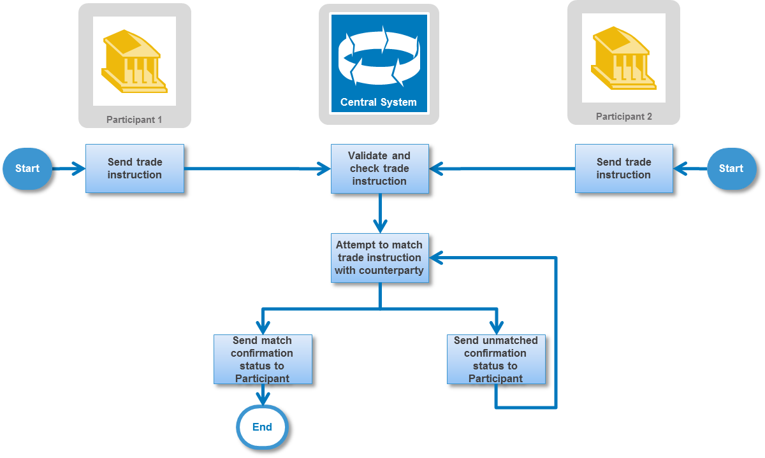

| **Descriptions of the BusinessActivities** | |
| --- | --- |
|  | **Initiator** |
| **Send Trade Instruction to Central System:** Once participants have executed a foreign exchange trade they send a trade instruction to the central system. | **Participant 1 and/or 2** |
| **Validate and check Trade Instruction:** The central system will check for duplicate messages, validate the message against XML schemas and check the content against internal party data. | **Central System** |
| **Attempt to match Trade Instruction with Counterparty:** If successful a new trade instruction is created and the central system attempts to match with a counterparty trade instruction. | **Central System** |
| **Send matched confirmation status:** The central system will then respond with a matched status notification. | **Central System** |
| **Send unmatched confirmation status:** The central system will then respond with an unmatched status notification and continue the process of attempting to match the trade instruction. | **Central System** |

## BusinessProcess – Amend Trade Instruction and Trade Notification

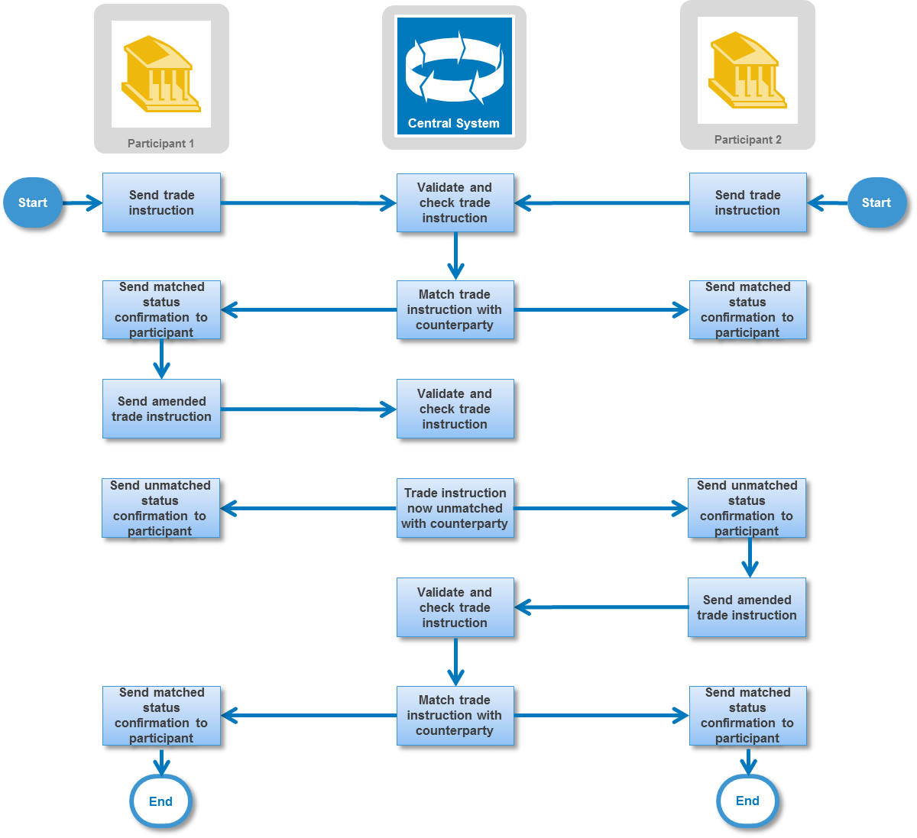

| **Descriptions of the BusinessActivities** | |
| --- | --- |
|  | **Initiator** |
| **Send Trade Instruction to Central System:** Once participants have executed a foreign exchange trade they send a trade instruction to the central system. | **Participant 1 and/or 2** |
| **Validate and check Trade Instruction:** The central system will check for duplicate messages, validate the message against XML schemas and check the content against internal party data. | **Central System** |
| **Match Trade Instruction with Counterparty:** A successful new trade instruction is created and the central system matches with a counterparty trade instruction. | **Central System** |
| **Send matched confirmation status:** The central system will then respond with a matched status notification. | **Central System** |
| **Send Amended Trade Instruction to Central System:** Participant sends an amended trade instruction to the central system. | **Participant 1** |
| **Validate and check Trade Instruction:** The central system will check for duplicate messages, validate the message against XML schemas and check the content against internal party data. | **Central System** |
| **Send unmatched confirmation status:** The central system will then respond with an unmatched status notification and continue the process of attempting to match the trade instruction. | **Central System** |
| **Send Amended Trade Instruction to Central System:** Participant sends an amended trade instruction to the central system. | **Participant 2** |
| **Validate and check Trade Instruction:** The central system will check for duplicate messages, validate the message against XML schemas and check the content against internal party data. | **Central System** |
| **Match Trade Instruction with Counterparty:** A successful a new trade instruction is created and the central system matches with a counterparty trade instruction. | **Central System** |
| **Send matched confirmation status:** The central system will then respond with a matched status notification. | **Central System** |

## BusinessProcess – Cancel /Withdrawal of Trade Instruction and Trade Notification

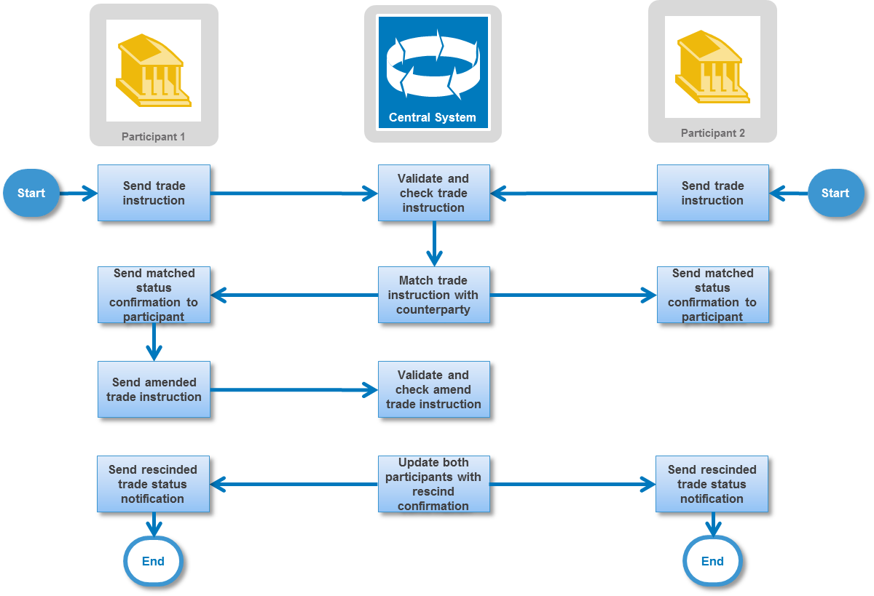

| **Descriptions of the BusinessActivities** | |
| --- | --- |
|  | **Initiator** |
| **Send Trade Instruction to Central System:** Once participants have executed a foreign exchange trade they send a trade instruction to the central system. | **Participant 1** |
| **Validate and check Trade Instruction:** The central system will check for duplicate messages, validate the message against XML schemas and check the content against internal party data. | **Central System** |
| **Attempt to match Trade Instruction with Counterparty:** If successful a new trade instruction is created and the central system attempts to match with a counterparty trade instruction. | **Central System** |
| **Send unmatched confirmation status:** The central system will then respond to both participants with an unmatched foreign exchange trade status notification. | **Central System** |
| **Send Trade Instruction Cancellation to Central System:** Participant sends trade instruction cancellation to the central system to rescind the previously sent trade instruction. | **Participant 1** |
| **Validate and check Trade Instruction Cancellation:** The central system will check for duplicate messages, validate the message against XML schemas and check the content against internal party data. | **Central System** |
| **Send Trade Status Notification of the rescind/cancellation to Participant 1:** The central system will then respond with a trade status notification notifying participant 1 of the rescind/cancellation of the trade.  **Send Withdrawal Notification of the rescind/cancellation to Participant 2:** The central system will then respond with a withdrawal notification to inform participant 2 that the alleged trade has been withdrawn. | **Central System** |

## BusinessProcess – Fixing of an NDF Opening Trade Instruction and Notification

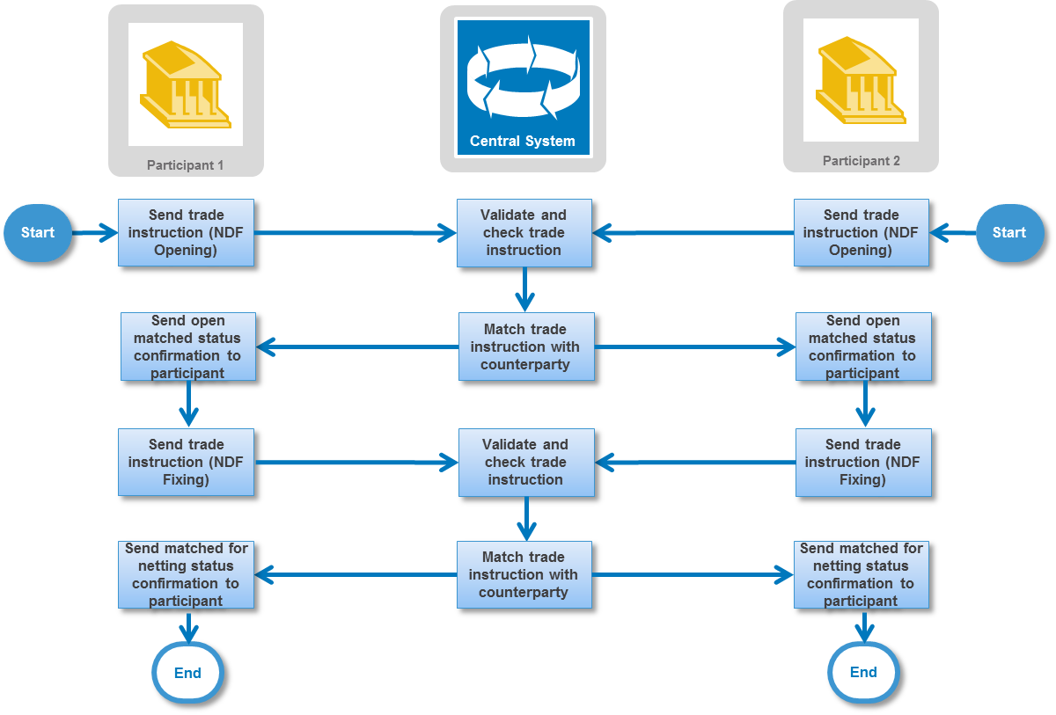

| **Descriptions of the BusinessActivities** | |
| --- | --- |
|  | **Initiator** |
| **Send NDF Opening Trade Instruction to Central System:** Once participants have executed an NDF they send an NDF opening trade instruction to the central system. | **Participant 1 and/or 2** |
| **Validate and check Trade Instruction:** The central system will check for duplicate messages, validate the message against XML schemas and check the content against internal party data. | **Central System** |
| **Match Trade Instruction with Counterparty:** A successful new trade instruction is created and the central system matches with a counterparty trade instruction. | **Central System** |
| **Send open matched confirmation status:** The central system will then respond with an open matched status notification. | **Central System** |
| **Send NDF Fixing Trade Instruction to Central System:** On fixing date, the Participant sends an NDF fixing trade instruction to the central system. | **Participant 1 and/or 2** |
| **Validate and check Trade Instruction:** The central system will check for duplicate messages, validate the message against XML schemas and check the content against internal party data. | **Central System** |
| **Match Trade Instruction with Counterparty:** A successful fixed NDF trade instruction is created and the central system matches with a counterparty NDF trade instruction. | **Central System** |
| **Send Matched for Netting confirmation status:** The central system will then respond with a matched for netting matched status notification. | **Central System** |

## BusinessProcess – Pay-In Schedule and Pay-In Schedule Event Acknowledgement

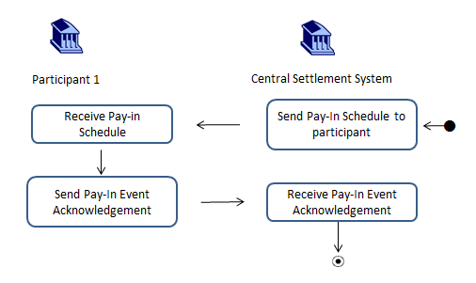

| **Descriptions of the BusinessActivities** | |
| --- | --- |
|  | **Initiator** |
| **Send Pay-In Schedule to Participant:** The pay-in schedule is sent by the central settlement system to the participant to provide notification of a series of timed payments scheduled for each currency at the time and date of the schedule generation. The central settlement system may send information about how the timed payments have been calculated. | **Central Settlement System** |
| **Receive Pay-In Schedule from Central Settlement System:** The participant receives the pay-in schedule from the central settlement system. | **Participant 1** |
| **Send Pay-In Event Acknowledgement:** The participant will then respond to the receipt of the pay-in schedule with the pay-in event acknowledgement. | **Participant 1** |
| **Receive Pay- In Event Acknowledgement from Participant 1:** The central settlement system receives the pay-in event acknowledgement from participant 1. | **Central Settlement System** |

## BusinessProcess – Pay-In Call and Pay-In Event Acknowledgement

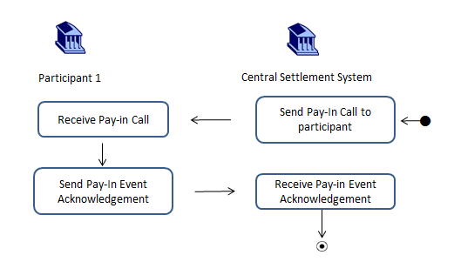

| **Descriptions of the BusinessActivities** | |
| --- | --- |
|  | **Initiator** |
| **Send Pay-In Call to Participant:** The pay-in call is sent by the central settlement system to request additional funding from a participant impacted by a failure situation and it details the required amount and currency along with alternative pay-in possibilities through other currencies | **Central Settlement System** |
| **Receive Pay-In Call from Central Settlement System:** The participant receives the pay-in call from the central settlement system. | **Participant 1** |
| **Send Pay-In Event Acknowledgement:** The participant will then respond to the receipt of the pay-in call with the pay-in event acknowledgement. | **Participant 1** |
| **Receive Pay- In Event Acknowledgement from Participant 1:** The central settlement system receives the pay-in event acknowledgement from participant 1. | **Central Settlement System** |

## BusinessProcess – Static Data Request and Report

| **Descriptions of the BusinessActivities** | |
| --- | --- |
|  | **Initiator** |
| **Send Static Data Request to the Central System:** Participants can interrogate central system’s static data using a static data request detailing specific data sets by sending the static data request. | **Participant 1** |
| **Receive Static Data Request from the Participant:** The central system receives the static data request from the participant and compiles the data for the report. | **Central System** |
| **Send Static Data Report to the Participant:** The central system will then send the static data report to the participant. | **Central System** |
| **Receive Static Data Report from the Central System:** The participant receives the static data report from the central system. | **Participant 1** |

## BusinessProcess – Net Report

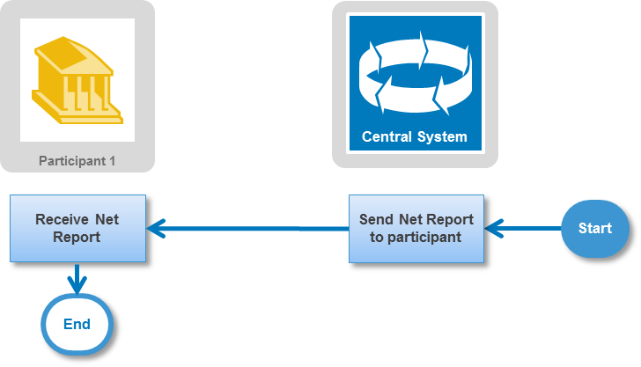

| **Descriptions of the BusinessActivities** | |
| --- | --- |
|  | **Initiator** |
| **Send Net Report to Participant:** The net report is sent by the central system to the participant to provide payment obligations per currency with other participants calculated as a result of the netting of transactions between participants. | **Central Settlement System** |
| **Receive Net Report from Central Settlement System:** The participant receives the net report from the central system. | **Participant 1** |

# BusinessTransactions

This section describes the message flows based on the activity diagrams documented above. It shows the typical exchanges of information in the context of a BusinessTransaction.

## Foreign Exchange Trade Instruction and Foreign Exchange Trade Status and Details Notification BusinessTransaction

Central system participants send in a FX trade instruction to be matched by the central settlement system. Usually, one trade instruction arrives which generates a FX trade status and details notification to both parties to inform the sender of the instruction that their instruction is not yet matched and to the counterparty to advise that this instruction is awaiting their instruction in order to match – this is referred to as unmatched alleged. Once the second instruction is received and successfully matched, then matching status messages are distributed to both participants. At the end of the settlement session there is a FX trade status bulk notification that the trade/s is/are settled.

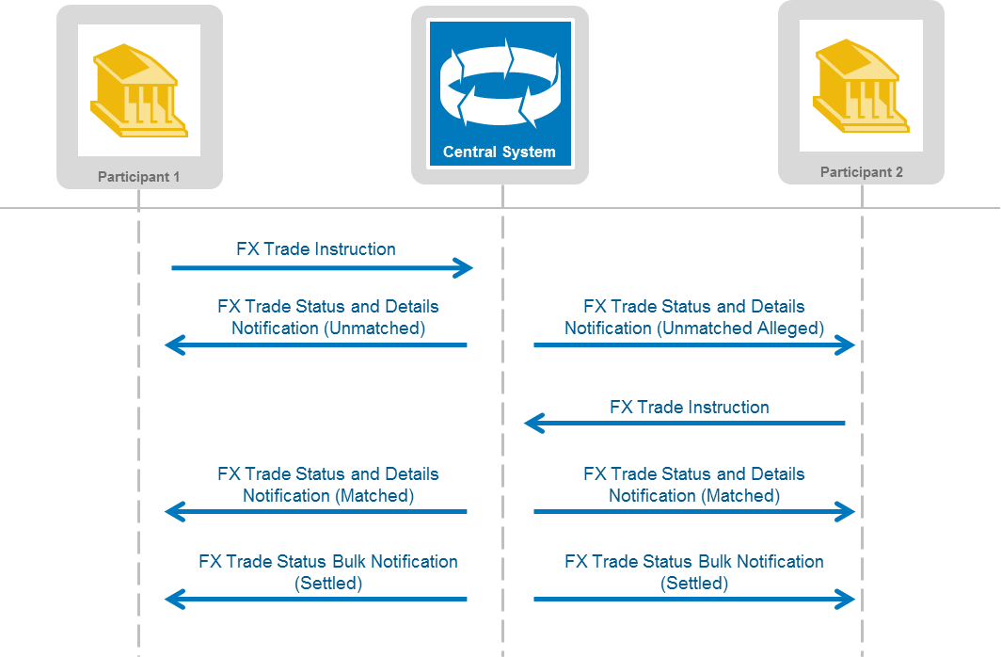

## Amend Trade Instruction and Trade Notification BusinessTransaction

As above, trade instructions are sent by two participants and matched by the central system. The participant 1 amends the original instruction. This results in the trade becoming unmatched again. Both participants are advised that the trade is unmatched. Participant 2 then sends their amendment and the trade is again in a matched status.

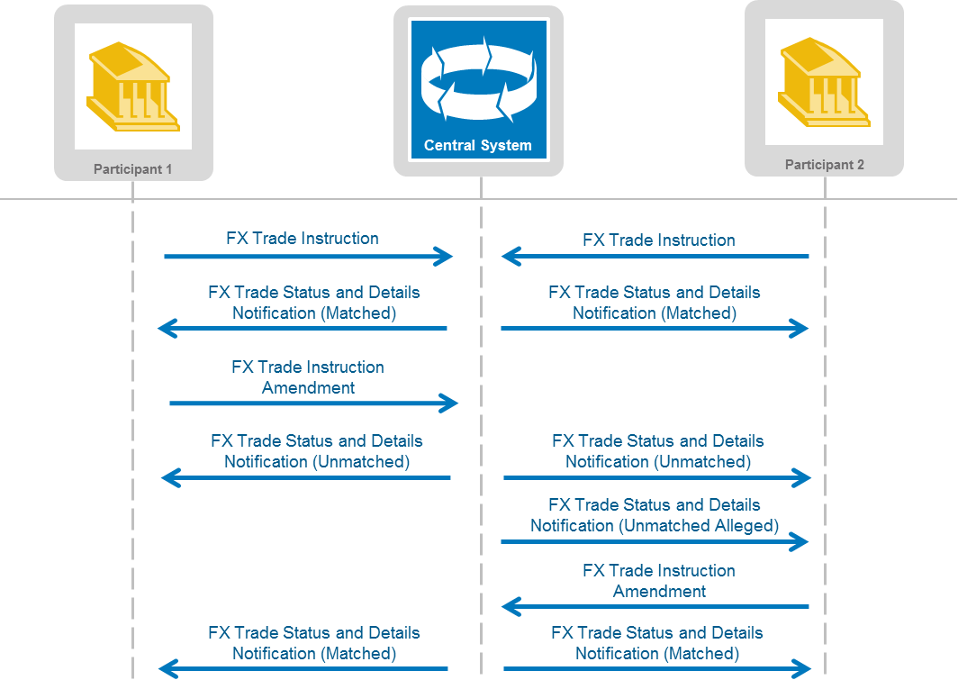

## Cancel/Withdrawal Trade Instruction and Trade Notification BusinessTransaction

As above in 6.1, trade instructions are sent by two participants and initially are unmatched and unmatched alleged. The participant 1 cancels or rescinds the FX trade instruction. From the central system there is a FX trade status notification sent to participant 1 to confirm that the trade instruction has been rescinded. For Participant 2 there is an FX trade withdrawal notification sent in order to withdraw the alleged trade.

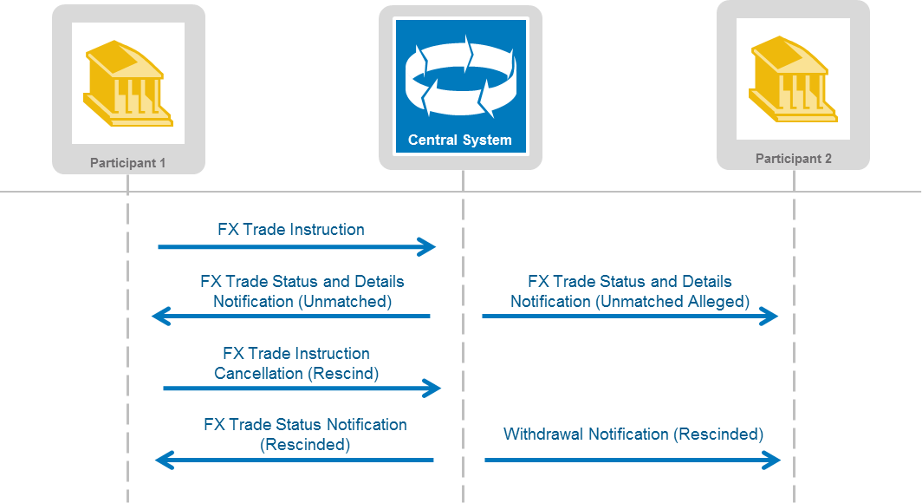

## Fixing of an NDF Opening Trade Instruction and Trade Notification BusinessTransaction

Central system participants send in two instructions each to complete and NDF trade. An NDF is made up of an opening instruction and a fixing instruction, all four instruction must match to complete the NDF. Like FX instructions in 6.1, NDF instructions must match between participants. Participant’s Fixing instructions must also match to the respective opening. Usually, the openings are received first and if not matched an unmatched alleged notification is sent to the counterparty participant. When the second successful opening is received the NDF is updated to Open Match and a corresponding notification is sent to both Participants. When one successful Fixing is received, the NDF is updated to Partial Fix and the corresponding notifications are sent to the Participants. The Participant who has yet to submit their Fixing will also receive an alleged Partial Fix notification. Upon receipt of the second fixing, the NDF is updated to Matched (for Netting) and a notification is sent to both participants.

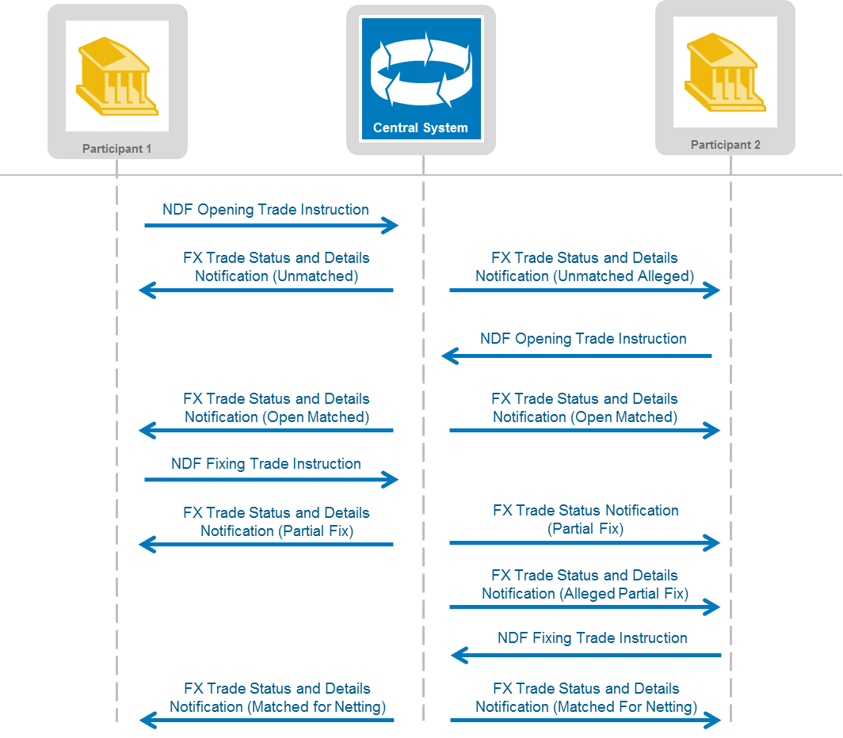

## Pay In Schedule and Pay-In Event Acknowledgement BusinessTransaction

Pay in schedules are sent to participants to provide notification of a series of timed payments scheduled for each currency at the time and date of the schedule generation. The central settlement system may send information about how the timed payments have been calculated. Participants are expected to acknowledge receipt of the pay in schedule by returning the pay in event acknowledgment with the pay in schedule reference.

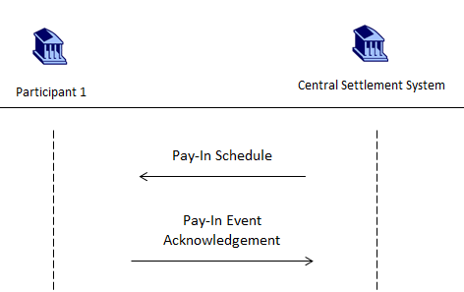

## Pay In Call and Pay-In Event Acknowledgement BusinessTransaction

Pay in calls are sent to participants by the central settlement system to request additional funding, for example when there has been an impact from a failure situation. This occurs outside of the normal pay in schedule timings. Participants are expected to acknowledge receipt of the pay in call by returning the pay in event acknowledgment with the pay in call reference.

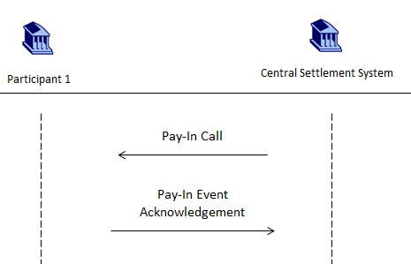

## Static Data Request and Report BusinessTransaction

It is possible for the participants to request static data from the central system using a static data request detailing specific data sets. The central system compiles the required data and responds to the participant with a static data report.

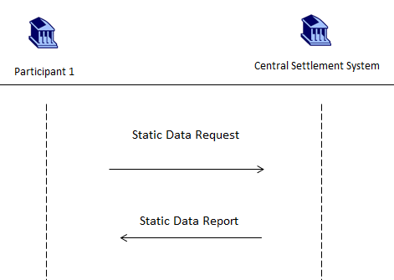

## Net Report BusinessTransaction

The net report is sent by the central system to the participant to provide payment obligations per currency with other participants calculated as a result of the netting of transactions between participants.

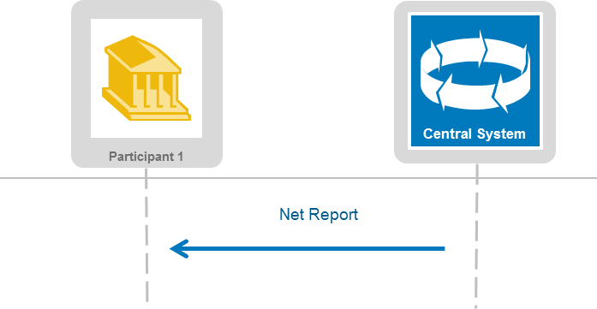.

# Examples

## Foreign Exchange Trade Instruction - fxtr.014.001.04

Description

This example describes a ForeignExchangeTradeInstruction sent by a participant “Bank 1” to the central system for matching and settlement of a foreign exchange trade executed with “Bank 2”.

Example

On 6 January 2014 “Bank 1” (BNKIUS33), a Participant in New York trades with “Bank 2” (BNKZAU2S), a Participant in Sydney. Bank 1 buys JPY 6,000,000,000 at 117.28 and sells USD.

Message Instance

<FXTradInstr>

<TradInf>

<TradDt>2014-01-06</TradDt>

<OrgtrRef>BANK144EG11</OrgtrRef>

<CmonRef>BNKIUS1234BNKZAU</CmonRef>

</TradInf>

<TradgSdId>

<SubmitgPty>

<AnyBIC>

<AnyBIC>BNKIUS33</AnyBIC>

</AnyBIC>

</SubmitgPty>

<TradPty>

<AnyBIC>

<AnyBIC>BNKIUS33</AnyBIC>

</AnyBIC>

</TradPty>

</TradgSdId>

<CtrPtySdId>

<SubmitgPty>

<AnyBIC>

<AnyBIC>BNKZAU2S</AnyBIC>

</AnyBIC>

</SubmitgPty>

<TradPty>

<AnyBIC>

<AnyBIC>BNKZAU2S</AnyBIC>

</AnyBIC>

</TradPty>

</CtrPtySdId>

<TradAmts>

<TradgSdBuyAmt Ccy =’JPY’>6000000000</TradgSdBuyAmt>

<TradgSdSellAmt Ccy=’USD’>51159618.01</TradgSdSellAmt>

<SttlmDt>2014-01-08</SttlmDt>

</TradAmts>

<AgrdRate>

<XchgRate>117.28</XchgRate>

</AgrdRate>

<RgltryRptg>

<TradgSdTxRptg>

<RptgJursdctn>CFTC</RptgJursdctn>

<TradgSdUnqTxIdr>

<UnqTxIdr>101BNKIUS3BANK144EG1100000000000000000011a </UnqTxIdr>

</TradgSdUnqTxIdr>

</TradgSdTxRptg>

</RgltryRptg>

</FXTradInstr>

## Foreign Exchange Trade Instruction Amendment - fxtr.015.001.04

Description

This example describes a ForeignExchangeTradeInstructionAmendment sent by a participant “Bank 1” to the central system amending the rate on the trade executed with “Bank 2” above to 118.28.

Example

On 6 January 2014 “Bank 1” (BNKIUS33), a Participant in New York amends the trade above (7.1) with “Bank 2” (BNKZAU2S), a Participant in Sydney. The rate is amended to 118.28.

Message Instance

<FXTradInstrAmdmnt>

<TradInf>

<TradDt>2014-01-06</TradDt>

<OrgtrRef>BANK144EG11</OrgtrRef>

<MtchgSysRef>

<MtchgSysUnqRef>G201401060000021</MtchgSysUnqRef>

</MtchgSysRef>

</TradInf>

<TradgSdId>

<SubmitgPty>

<AnyBIC>

<AnyBIC>BNKIUS33</AnyBIC>

</AnyBIC>

</SubmitgPty>

<TradPty>

<AnyBIC>

<AnyBIC>BNKIUS33</AnyBIC>

</AnyBIC>

</TradPty>

</TradgSdId>

<CtrPtySdId>

<SubmitgPty>

<AnyBIC>

<AnyBIC>BNKZAU2S</AnyBIC>

</AnyBIC>

</SubmitgPty>

<TradPty>

<AnyBIC>

<AnyBIC>BNKZAU2S</AnyBIC>

</AnyBIC>

</TradPty>

</CtrPtySdId>

<TradAmts>

<TradgSdBuyAmt Ccy=’JPY’>6000000000</TradgSdBuyAmt>

<TradgSdSellAmt Ccy=’USD’>50727088.27</TradgSdSellAmt>

<SttlmDt>2014-01-08</SttlmDt>

</TradAmts>

<AgrdRate>

<XchgRate>118.28</XchgRate>

</AgrdRate>

</FXTradInstrAmdmnt>

## Foreign Exchange Trade Instruction Cancellation - fxtr.016.001.04

Description

This example describes a ForeignExchangeTradeInstructionCancellation sent by a participant “Bank 1” to the central system cancelling the trade executed with “Bank 2” above in 7.1.

Example

On 6 January 2014 “Bank 1” (BNKIUS33), a Participant in New York cancels the trade above (7.1) with “Bank 2” (BNKZAU2S), a Participant in Sydney.

**Message Instance**

<FXTradInstrCxl>

<TradInf>

<TradDt>2014-01-06</TradDt>

<OrgtrRef>BANK144EG11</OrgtrRef>

<MtchgSysRef>

<MtchgSysUnqRef>G201401060000022</MtchgSysUnqRef>

</MtchgSysRef>

</TradInf>

<TradgSdId>

<SubmitgPty>

<AnyBIC>

<AnyBIC>BNKIUS33</AnyBIC>

</AnyBIC>

</SubmitgPty>

<TradPty>

<AnyBIC>

<AnyBIC>BNKIUS33</AnyBIC>

</AnyBIC>

</TradPty>

</TradgSdId>

<CtrPtySdId>

<SubmitgPty>

<AnyBIC>

<AnyBIC>BNKZAU2S</AnyBIC>

</AnyBIC>

</SubmitgPty>

<TradPty>

<AnyBIC>

<AnyBIC>BNKZAU2S</AnyBIC>

</AnyBIC>

</TradPty>

</CtrPtySdId>

<TradAmts>

<TradgSdBuyAmt Ccy=’JPY’>6000000000</TradgSdBuyAmt>

<TradgSdSellAmt Ccy=’USD’>50727088.27</TradgSdSellAmt>

<SttlmDt>2014-01-08</SttlmDt>

</TradAmts>

</FXTradInstrCxl>

## Foreign Exchange Trade Withdrawal Notification - fxtr.013.001.03

Description

This example describes a ForeignExchangeTradeWithdrawalNotification of an Alleged Trade sent by the central system to “Bank 2” to communicate the trade instruction concerned has been rescinded by “Bank 1”.

Example

Below is an example Foreign Exchange Trade WithdrawalNotification Alleged Trade withdrawal sent to Bank 2, communicating the Rescinded status of Bank 1’s Trade.

**Message Instance**

<FXTradWdrwlNtfctn>

<MsgId>M201401060000001</MsgId>

<MtchgSysUnqRef>G201401060000001</MtchgSysUnqRef>

<WdrwlRsn>

<WdrwlRsnCd>RSCD</WdrwlRsnCd>

<WdrwlRsnSubCd>SRST</WdrwlRsnSubCd>

</WdrwlRsn>

<SttlmSsnIdr>MAIN</SttlmSsnIdr>

</FXTradWdrwlNtfctn >

## Foreign Exchange Trade Status Notification - fxtr.008.001.06

Description

This example describes a ForeignExchangeTradeStatusNotification sent by the central system to “Bank 1” stating that a previously submitted ForeignExchangeTradeInstruction is now with a status of rescinded.

Example

Below is the body of the Rescinded Foreign Exchange Trade Status Notification sent to Bank 1 BNKIUS33 from a previously submitted Foreign Exchange Trade Instruction.

**Message Instance**

<FXTradStsNtfctn>

<TradData>

<MsgId>M201401060000002</MsgId>

<MtchgSysUnqRef>G201401060000001</MtchgSysUnqRef>

<StsOrgtr>CLSBUS33 </StsOrgtr>

<CurSts>

<StsCd>

<Cd>RSCD</Cd>

</StsCd>

<SubStsCd>0001</SubStsCd>

</CurSts>

<CurStsDtTm>2014-01-06T08:01:15.000</CurStsDtTm>

<SttlmSsnIdr>MAIN</SttlmSsnIdr>

</TradData>

</FXTradStsNtfctn>

## Foreign Exchange Trade Status And Details Notification - fxtr.017.001.04

Description

This example describes a ForeignExchangeTradeStatusAnd DetailsNotification sent by the central system to “Bank 1” relating to a previously submitted ForeignExchangeTradeInstruction with the current status of unmatched. This notification messages contains all the details of the trade concerned.

Example

Below is the body of the unmatched Foreign Exchange Trade Status and Details Notification message sent to Bank 1 BNKIUS33 from a previously submitted Foreign Exchange Trade Instruction.

**Message Instance**

<FXTradStsAndDtlsNtfctn>

<StsDtls>

<MtchgSysUnqRef>G201401060000001</MtchgSysUnqRef>

<StsOrgtr>CLSBUS33</StsOrgtr>

<CurSts>

<StsCd>

<Cd>UMTC</Cd>

</StsCd>

<SubStsCd>IURT</SubStsCd>

</CurSts>

<CurStsDtTm>2014-01-06T08:00:01.000</CurStsDtTm>

</StsDtls>

<TradInf>

<TradDt>2014-01-06</TradDt>

<MsgId>M201401060000001</MsgId>

<OrgtrRef>BANK167EG11</OrgtrRef>

<PdctTp>FORX</PdctTp>

<SttlmSsnIdr>MAIN</SttlmSsnIdr>

<SpltTradInd>0</SpltTradInd>

</TradInf>

<TradgSdId>

<SubmitgPty>

<AnyBIC>

<AnyBIC>BNKIUS33XXX</AnyBIC>

</AnyBIC>

</SubmitgPty>

<TradPty>

<AnyBIC>

<AnyBIC>BNKIUS33XXX</AnyBIC>

</AnyBIC>

</TradPty>

</TradgSdId>

<CtrPtySdId>

<SubmitgPty>

<AnyBIC>

<AnyBIC>BNKZAU2SXXX</AnyBIC>

</AnyBIC>

</SubmitgPty>

<TradPty>

<AnyBIC>

<AnyBIC>BNKZAU2SXXX</AnyBIC>

</AnyBIC>

</TradPty>

</CtrPtySdId>

<TradAmts>

<TradgSdBuyAmt Ccy ="JPY">6000000000</TradgSdBuyAmt>

<TradgSdSellAmt Ccy="USD">51159618.01</TradgSdSellAmt>

<SttlmDt>2014-01-08</SttlmDt>

</TradAmts>

<AgrdRate>

<XchgRate>117.28</XchgRate>

</AgrdRate>

<RgltryRptg>

<RptgJursdctn>CFTC</RptgJursdctn>

<TradgSdUnqTxIdr>

<UnqTxIdr>101BNKIUS3BANK167EG1100000000000000000011a </UnqTxIdr>

</TradgSdUnqTxIdr>

</RgltryRptg>

</FXTradStsAndDtlsNtfctn>

## Foreign Exchange Trade Bulk Status Notification - fxtr.030.001.04

Description

This example describes a ForeignExchangeTradeBulkNotification sent by the central system notifying all the trades that have been selected for settlement.

Example

This is an example for an FX Trade Status Bulk Notification delivering the Settlement Mature Notification.

**Message Instance**

<FXTradBlkStsNtfctn>

<StsDtls>

<MsgId>M201401060000001</MsgId>

<StsOrgtr>CLSBUS33</StsOrgtr>

<CurSts>

<StsCd>

<Cd>SMAT</Cd>

</StsCd>

</CurSts>

<CurStsDtTm>2014-01-08T00:10:01.000</CurStsDtTm>

</StsDtls>

<TradData>

<MtchgSysUnqRef>ASMA</MtchgSysUnqRef>

<CurSttlmDt>2014-01-08</CurSttlmDt>

<SttlmSsnIdr>MAIN</SttlmSsnIdr>

</TradData>

</FXTradBlkStsNtfctn>

## Foreign Exchange NDF Opening Trade Instruction - fxtr.014.001.04

Description

This example describes a ForeignExchangeTradeInstruction (NDF Opening) sent by a participant “Bank 1” to the central system for matching of a foreign exchange trade executed with “Bank 2”.

Example

On 16th March 2016 “Bank 1” (BNKAGB2L), a Participant in London agrees an NDF with “Bank 2” (BNKBDE2L), a Participant in Frankfurt. Bank 1 buys THB 3800 at 47.5 and sells 80 GBP for the opening. The settlement currency is GBP.

Message Instance

<FXTradInstr>

<TradInf>

<TradDt>2016-03-16</TradDt>

<OrgtrRef>BNKAGB2LREF1</OrgtrRef>

<PdctTp>ANDF</PdctTp>

<SttlmSsnIdr>CNET</SttlmSsnIdr>

</TradInf>

<TradgSdId>

<SubmitgPty>

<AnyBIC>

<AnyBIC>BNKAGB2LXXX</AnyBIC>

</AnyBIC>

</SubmitgPty>

<TradPty>

<AnyBIC>

<AnyBIC>BNKAGB2LXXX</AnyBIC>

</AnyBIC>

</TradPty>

</TradgSdId>

<CtrPtySdId>

<SubmitgPty>

<AnyBIC>

<AnyBIC>BNKBDE2LXXX</AnyBIC>

</AnyBIC>

</SubmitgPty>

<TradPty>

<AnyBIC>

<AnyBIC>BNKBDE2LXXX</AnyBIC>

</AnyBIC>

</TradPty>

</CtrPtySdId>

<TradAmts>

<TradgSdBuyAmt Ccy="THB">3800</TradgSdBuyAmt>

<TradgSdSellAmt Ccy="GBP">80</TradgSdSellAmt>

<SttlmDt>2016-03-21</SttlmDt>

</TradAmts>

<AgrdRate>

<XchgRate>47.5</XchgRate>

</AgrdRate>

<NDFConds>

<OpngInd>1</OpngInd>

<OpngFxgConds>

<OpngConds>

<SttlmCcy>GBP</SttlmCcy>

<ValtnDt>2016-03-18</ValtnDt>

<SttlmRateSrc>

<RateSrc>EMT00</RateSrc>

<Tm>1000</Tm>

<CtryCd>GB</CtryCd>

<LctnCd>LN</LctnCd>

</SttlmRateSrc>

</OpngConds>

</OpngFxgConds>

</NDFConds>

<TradgSdSttlmInstrs>

<RcvgAgt>

<AnyBIC>

<AnyBIC>CLSBGB20XXX</AnyBIC>

</AnyBIC>

</RcvgAgt>

</TradgSdSttlmInstrs>

<RgltryRptg>

<TradgSdTxRptg>

<RptgJursdctn>ESMA</RptgJursdctn>

<TradgSdUnqTxIdr>

<UnqTxIdr>BNKAGB2LXXXLEI000001BNKAGB2LREF1</UnqTxIdr>

</TradgSdUnqTxIdr>

</TradgSdTxRptg>

</RgltryRptg>

</FXTradInstr>

## Foreign Exchange NDF Fixing Trade Instruction - fxtr.014.001.04

Description

This example describes a ForeignExchangeTradeInstruction (NDF Fixing) sent by a participant “Bank 1” to the central system for matching of a foreign exchange trade executed with “Bank 2”.

Example

On 18thn March 2016 “Bank 1” (BNKAGB2L), a Participant in London fixes an NDF trades with “Bank 2” (BNKBDE2L), a Participant in Frankfurt. Bank 1 buys back 79 GBP at 48.101 for the original THB amount of 3800.

Message Instance

<FXTradInstr>

<TradInf>

<TradDt>2016-03-18</TradDt>

<OrgtrRef>BNKAGB2LREF2</OrgtrRef>

<PdctTp>ANDF</PdctTp>

<SttlmSsnIdr>CNET</SttlmSsnIdr>

</TradInf>

<TradgSdId>

<SubmitgPty>

<AnyBIC>

<AnyBIC>BNKAGB2LXXX</AnyBIC>

</AnyBIC>

</SubmitgPty>

<TradPty>

<AnyBIC>

<AnyBIC>BNKAGB2LXXX</AnyBIC>

</AnyBIC>

</TradPty>

</TradgSdId>

<CtrPtySdId>

<SubmitgPty>

<AnyBIC>

<AnyBIC>BNKBDE2LXXX</AnyBIC>

</AnyBIC>

</SubmitgPty>

<TradPty>

<AnyBIC>

<AnyBIC>BNKBDE2LXXX</AnyBIC>

</AnyBIC>

</TradPty>

</CtrPtySdId>

<TradAmts>

<TradgSdBuyAmt Ccy="GBP">79</TradgSdBuyAmt>

<TradgSdSellAmt Ccy="THB">3800</TradgSdSellAmt>

<SttlmDt>2016-03-21</SttlmDt>

</TradAmts>

<AgrdRate>

<XchgRate>48.101</XchgRate>

</AgrdRate>

<NDFConds>

<OpngInd>0</OpngInd>

<OpngFxgConds>

<OpngConfRef>BNKAGB2LREF1</OpngConfRef>

</OpngFxgConds>

</NDFConds>

<TradgSdSttlmInstrs>

<RcvgAgt>

<AnyBIC>

<AnyBIC>CLSBGB20XXX</AnyBIC>

</AnyBIC>

</RcvgAgt>

</TradgSdSttlmInstrs>

<RgltryRptg>

<TradgSdTxRptg>

<RptgJursdctn>ESMA</RptgJursdctn>

<TradgSdUnqTxIdr>

<UnqTxIdr>BNKAGB2LXXXLEI000001BNKAGB2LREF1</UnqTxIdr>

</TradgSdUnqTxIdr>

</TradgSdTxRptg>

</RgltryRptg>

</FXTradInstr>

## Foreign Exchange Trade Status and Details Notification (NDF) - fxtr.017.001.04

Description

This example describes a ForeignExchangeTradeStatusAndDetailsNotification sent by the central system to “Bank 1” relating to a previously submitted NDF ForeignExchangeTradeInstruction with the current status of Partially Fixed. This notification messages contains all the details of the NDF concerned.

Example

Below is the body of the Partially Fixed Foreign Exchange Trade Status and Details Notification message sent to Bank 1 BNKAGB2L from a previously submitted NDF Foreign Exchange Trade Instruction.

<FXTradStsAndDtlsNtfctn>

<StsDtls>

<MtchgSysUnqRef>G201603160000001</MtchgSysUnqRef>

<MtchgSysMtchgRef>TG201603160000001</MtchgSysMtchgRef>

<MtchgSysMtchdSdRef>G201603160000002</MtchgSysMtchdSdRef>

<StsOrgtr>CLSBUS33XXX</StsOrgtr>

<CurSts>

<StsCd>

<Cd>PFIX</Cd>

</StsCd>

<SubStsCd>IURT</SubStsCd>

</CurSts>

<CurStsDtTm>2016-03-18T09:30:47Z</CurStsDtTm>

</StsDtls>

<TradInf>

<TradDt>2016-03-16</TradDt>

<MsgId>M201603180000001</MsgId>

<OrgtrRef>BNKAGB2LREF1</OrgtrRef>

<PdctTp>ANDF</PdctTp>

<SpltTradInd>0</SpltTradInd>

</TradInf>

<TradgSdId>

<SubmitgPty>

<AnyBIC>

<AnyBIC>BNKAGB2LXXX</AnyBIC>

</AnyBIC>

</SubmitgPty>

<TradPty>

<AnyBIC>

<AnyBIC>BNKAGB2LXXX</AnyBIC>

</AnyBIC>

</TradPty>

</TradgSdId>

<CtrPtySdId>

<SubmitgPty>

<AnyBIC>

<AnyBIC>BNKBDE2LXXX</AnyBIC>

</AnyBIC>

</SubmitgPty>

<TradPty>

<AnyBIC>

<AnyBIC>BNKBDE2LXXX</AnyBIC>

</AnyBIC>

</TradPty>

</CtrPtySdId>

<TradAmts>

<TradgSdBuyAmt Ccy="THB">3800</TradgSdBuyAmt>

<TradgSdSellAmt Ccy="GBP">80</TradgSdSellAmt>

<SttlmDt>2016-03-21</SttlmDt>

</TradAmts>

<AgrdRate>

<XchgRate>47.5</XchgRate>

</AgrdRate>

<NDFConds>

<OpngConds>

<SttlmCcy>GBP</SttlmCcy>

<ValtnDt>2016-03-18</ValtnDt>

<SttlmRateSrc>

<RateSrc>EMT00</RateSrc>

<Tm>1000</Tm>

<CtryCd>GB</CtryCd>

<LctnCd>LN</LctnCd>

</SttlmRateSrc>

</OpngConds>

<FxgConds>

<TradDt>2016-03-18</TradDt>

<OrgtrRef>BNKAGB2LREF2</OrgtrRef>

<TradgSdBuyAmt Ccy="GBP">79</TradgSdBuyAmt>

<TradgSdSellAmt Ccy="THB">3800</TradgSdSellAmt>

<XchgRate>48.101</XchgRate>

</FxgConds>

</NDFConds>

<TradgSdSttlmInstrs>

<RcvgAgt>

<AnyBIC>

<AnyBIC>CLSBGB20XXX</AnyBIC>

</AnyBIC>

</RcvgAgt>

</TradgSdSttlmInstrs>

<RgltryRptg>

<TradgSdTxRptg>

<RptgJursdctn>ESMA</RptgJursdctn>

<TradgSdUnqTxIdr>

<UnqTxIdr>BNKAGB2LXXXLEI000001BNKAGB2LREF1</UnqTxIdr>

</TradgSdUnqTxIdr>

</TradgSdTxRptg>

</RgltryRptg>

</FXTradStsAndDtlsNtfctn>

## Message Reject – admi.002.001.01

**Description**

This example describes a MessageReject sent by the central system after validation of a previously received message.

**Example**

There is a mistake in the date time format in a previously sent message and the central system notifies the sender.

**Message instance**

< admi.002.001.01>

<RltdRef>

<Ref>ND234</Ref>

</RltdRef>

<Rsn>

<RjctgPtyRsn>Wrong date time format</RjctgPtyRsn>

</Rsn>

</ admi.002.001.01>

## System Event Notification – admi.004.001.02

**Description**

This example describes a SystemEventNotification sent by the central system to notify of an event in the central system.

**Example**

The event notified is identified by the code ‘C100’.

**Message Instance**

<SysEvtNtfnV01>

<EvtInf>

<EvtCd>C100</EvtCd>

</EvtInf>

</SysEvtNtfnV01>

## Static Data Request - admi.009.001.02

Description

This example describes a StaticDataRequest sent by a participant to the central system requesting the static data for all the eligible participant BIC’s in the central system.

Example

This is an example of a request for a list of all eligible participant BICs in the central system.

**Message Instance**

<StatcDataReq>

<MsgId>M201401060000025</MsgId>

<DataReqDtls>

<Tp>SMBIC </Tp>

</DataReqDtls>

</StatcDataReq>

## Static Data Report - admi.010.001.02

Description

This example describes a StaticDataReport that is produced by the central system and sent to the participant listing all the static data for all the eligible participant BIC’s in the central system.

Example

This is an example of a list of all the eligible participant BIC’s in the central system as at the date requested.

**Message Instance**

<StatcDataRpt>

<MsgId>M201401060000035</MsgId>

<RptDtls>

<Tp>SMBIC</Tp>

<ReqRef>M201401060000025</ReqRef>

<RptKey>

<Key>BIC </Key>

<RptData>

<Nm>BANKGB2LXXX </Nm>

<Val>BRIT BNK1 </Val>

</RptData>

<RptData>

<Nm>BANKUS33XXX </Nm>

<Val>USA BANK1 </Val>

</RptData>

</RptKey>

</RptDtls>

</StatcDataRpt>

## System Event Acknowledgment - admi.011.001.01

Description

This example describes a SystemEventAcknowledgement that is produced by a participant and sent to the central system acknowledging the system event 12345 in the MAIN settlement session.

Example

This is a SystemEventAcknowledgement for system event 12345.

**Message Instance**

<SysEvtAck>

<MsgId> M201401060000045</MsgId>

<OrgtrRef>12345</OrgtrRef>

<SttlmSsnIdr>MAIN</SttlmSsnIdr>

</SysEvtAck>

## Pay In Call - camt.061.001.02

Description

This example describes a PayInCall sent by the central settlement system to a participant for a PayInCall for value for the following currencies USD, JPY, CAD, GBP and EUR, value date 8th of January.

Example

This is an example of a Pay In Call for value.

**Message Instance**

<PayInCall>

<PtyId>

<NmAndAdr>

<Nm>MemberShortName</Nm>

</NmAndAdr>

</PtyId>

<RptData>

<MsgId>M201401060000001</MsgId>

<ValDt>2014-01-08 </ValDt>

<DtAndTmStmp>2014-01-08T00:00:34</DtAndTmStmp>

<Tp>CFAV</Tp>

<SttlmSsnIdr>MAIN</SttlmSsnIdr>

<AcctVal>

<BaseCcyItm Ccy="USD">5000000</BaseCcyItm>

<AltrnCcyItm Ccy="JPY">151548896</AltrnCcyItm>

<AltrnCcyItm Ccy="EUR">48973435</AltrnCcyItm>

<AltrnCcyItm Ccy="CAD">2675234</AltrnCcyItm>

<AltrnCcyItm Ccy="GBP">1967352</AltrnCcyItm>

</AcctVal>

</RptData>

</PayInCall>

## Pay In Schedule - camt.062.001.03

Description

This example describes a PayInSchedule sent by the central settlement system to a participant for an official initial pay in schedule for the following currencies USD, JPY, KRW, GBP and CHF, value date 8th of January.

Example

This is an example of the Pay-In schedule.

**Message Instance**

<PayInSchdl>

<PtyId>

<NmAndAdr>

<Nm>MemberShortName</Nm>

</NmAndAdr>

</PtyId>

<RptData>

<MsgId>M201401060000001</MsgId>

<ValDt>2014-01-08</ValDt>

<DtAndTmStmp>2014-01-08T00:00:34</DtAndTmStmp>

<Tp>OFFI</Tp>

<SchdlTp>IPIS</SchdlTp>

<SttlmSsnIdr>MAIN</SttlmSsnIdr>

</RptData>

<PayInSchdlLngBal>

<Bal Ccy = ‘USD’>1000</Bal>

</PayInSchdlLngBal>

<PayInSchdlLngBal>

<Bal Ccy = ‘GBP’>2000</Bal>

</PayInSchdlLngBal>

<PayInSchdlLngBal>

<Bal Ccy = ‘JPY’>3000</Bal>

</PayInSchdlLngBal>

<PayInSchdlItm>

<Amt Ccy = ‘KRW’>10000</Amt>

<Ddln>2014-01-06T10:00:00</Ddln>

</PayInSchdlItm>

<PayInSchdlItm>

<Amt Ccy = ‘CHF’>1000</Amt>

<Ddln>2014-01-06T15:00:00</Ddln>

</PayInSchdlItm>

<PayInFctrs>

<AggtShrtPosLmt Ccy = ‘USD’>10000</AggtShrtPosLmt>

<CcyFctrs>

<Ccy>GBP</Ccy>

<ShrtPosLmt>5000</ShrtPosLmt>

<MinPayInAmt>500</MinPayInAmt>

<VoltlyMrgn>10</VoltlyMrgn>

<Rate>

<XchgRate>1.5</XchgRate>

<UnitCcy>GBP</UnitCcy>

<QtdCcy>USD</QtdCcy>

</Rate>

</CcyFctrs>

<CcyFctrs>

<Ccy>KRW</Ccy>

<ShrtPosLmt>10000</ShrtPosLmt>

<MinPayInAmt>1000</MinPayInAmt>

<VoltlyMrgn>5</VoltlyMrgn>

<Rate>

<XchgRate>123</XchgRate>

<UnitCcy>USD</UnitCcy>

<QtdCcy>KRW</QtdCcy>

</Rate>

</CcyFctrs>

</PayInFctrs>

</PayInSchdl>

## Pay In Event Acknowledgement - camt.063.001.02

Description

This example describes a PayInEventAcknowledgement sent by the participant to the central settlement system to confirm receipt of an official PayInSchedule with the reference if the PayInSchedule.

Example

This is an example of the Pay-In Event Acknowledgement.

**Message Instance**

<PayInEvtAck>

<MsgId> M201401060000032</MsgId>

<AckDtls>

<PayInSchdlRef> M201401060000001</PayInSchdlRef>

</AckDtls>

</PayInEvtAck>

## Net Report – camt.088.001.01

Description

This example describes a NetReport sent by the central system to the participant to provide details of the payment obligations per currency with other participants.

The central system provides a report with obligations in GBP for BANK AGB with BANK BGB and BANK CGB at the 09:00:00 Netting Cut-off. Note this report consists of three obligations involving two of BANK AGB’s Netting Groups and one Netting Group from each Counterparty.

The table describes the data detailing the payment obligations between the Participant and its Counterparties. Note that the Obligation Identification values are shared across reports, i.e. each participant will receive the same Obligation and Obligation Identification from their point of view.

<NetRpt>

<NetRptData>

<MsgId>M201610310000001</MsgId>

<CreDtTm>2016-10-31T09:00:00</CreDtTm>

<NetgCutOffTm>09:00:00</NetgCutOffTm>

<RptDt>2016-10-31</RptDt>

<ValDt>2016-11-01</ValDt>

<RptTp>CURR</RptTp>

<NetRptSvcr>

<AnyBIC>

<AnyBIC>CLSBUS33XXX</AnyBIC>

</AnyBIC>

</NetRptSvcr>

</NetRptData>

<NetSvcPtcptId>

<PtyId>

<PtyNm>BANK AGB</PtyNm>

</PtyId>

</NetSvcPtcptId>

<NetOblgtnDtls>

<OblgtnId>B201603180000001</OblgtnId>

<Amt Ccy="GBP">10000</Amt>

<PtcptNetgId>

<NetgGrpId>Group AGB 1</NetgGrpId>

</PtcptNetgId>

<OblgtnDrctn>RECE</OblgtnDrctn>

<CtrPtyNetgId>

<NetgGrpId>Group BGB 1</NetgGrpId>

</CtrPtyNetgId>

<NetSvcCtrPtyId>

<PtyId>

<PtyNm>BANK BGB</PtyNm>

</PtyId>

</NetSvcCtrPtyId>

<TxsNb>5</TxsNb>

</NetOblgtnDtls>

<NetOblgtnDtls>

<OblgtnId>B201603180000002</OblgtnId>

<Amt Ccy="GBP">20000</Amt>

<PtcptNetgId>

<NetgGrpId>Group AGB 1</NetgGrpId>

</PtcptNetgId>

<OblgtnDrctn>PAYM</OblgtnDrctn>

<CtrPtyNetgId>

<NetgGrpId>Group BGB 2</NetgGrpId>

</CtrPtyNetgId>

<NetSvcCtrPtyId>

<PtyId>

<PtyNm>BANK BGB</PtyNm>

</PtyId>

</NetSvcCtrPtyId>

<TxsNb>9</TxsNb>

</NetOblgtnDtls>

<NetOblgtnDtls>

<OblgtnId>B201603180000003</OblgtnId>

<Amt Ccy="GBP">50000</Amt>

<PtcptNetgId>

<NetgGrpId>Group AGB 2</NetgGrpId>

</PtcptNetgId>

<OblgtnDrctn> PAYM </OblgtnDrctn>

<CtrPtyNetgId>

<NetgGrpId>Group CGB 1</NetgGrpId>

</CtrPtyNetgId>

<NetSvcCtrPtyId>

<PtyId>

<PtyNm>BANK CGB</PtyNm>

</PtyId>

</NetSvcCtrPtyId>

<TxsNb>12</TxsNb>

</NetOblgtnDtls>

</NetRpt>

# Revision Record

|  |  |  |  |  |
| --- | --- | --- | --- | --- |
| **Revision** | **Date** | **Author** | **Description** | **Sections affected** |
| 1.0 | 28/01/2015 | CLS | First version for SEG submission | All |
| 2.0 | 05/09/2015 | ISO 20022 RA | Editing for publication | 2, 3, 4, 7, 8 |
| 2.1 | 18/11/2016 | CLS | Updated version for SEG submission | All |
| 3.0 | 29/03/2017 | ISO 20022 RA | Editing for publication | All |
| 3.1 | 07/01/2019 | ISO 20022 RA | Corrected sample | 7.1 |
|  |  |  |  |  |

**Disclaimer**:

Although the Registration Authority has used all reasonable efforts to ensure accuracy of the contents of the iso20022.org website and the information published thereon, the Registration Authority assumes no liability whatsoever for any inadvertent errors or omissions that may appear thereon. Moreover, the information is provided on an "as is" basis. The Registration Authority disclaims all warranties and conditions, either express or implied, including but not limited to implied warranties of merchantability, title, non-infringement and fitness for a particular purpose.

The Registration Authority shall not be liable for any direct, indirect, special or consequential damages arising out of the use of the information published on the iso20022.org website, even if the Registration Authority has been advised of the possibility of such damages.

**Intellectual Property Rights**:

The ISO 20022 MessageDefinitions described in this document were contributed by CLS Bank. The ISO 20022 IPR policy is available at www.ISO20022.org > About ISO 20022 > Intellectual Property Rights.